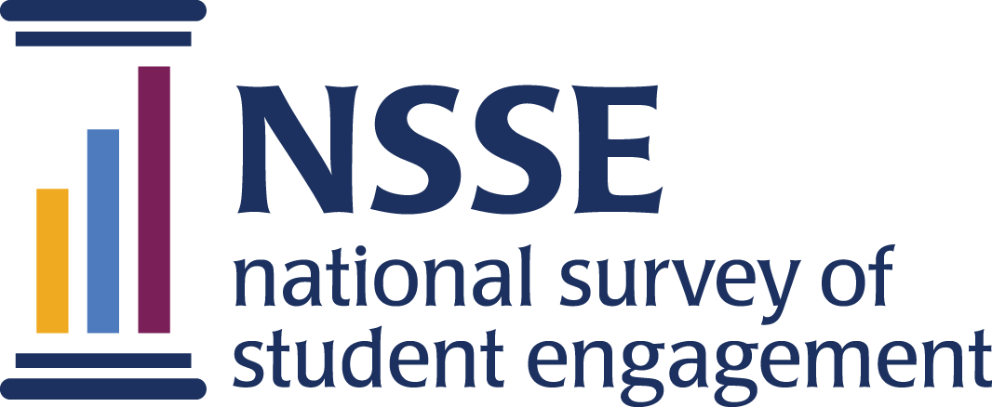
NSSE 2024 Data Codebooks
Experiences with Information Literacy
Topical Module

This module, updated for NSSE 2024, was developed in collaboration with college and university librarians from the Association of College & Research Libraries. Items focus on students' use of information sources, research-based inquiry, and experiences traditionally associated with research libraries. The module complements questions on the core survey about reflective & integrative learning, higher-order learning, and assigned reading and writing.
Survey questions are listed in the order that students received them. Response options appear in italics beneath. Variable names appear in brackets (e.g., INLsource) after each item. Items that are recoded (e.g., reversed response values) or derived (new computed values such as age category or total number of written pages) from original question(s) are shaded and prefaced by a bracket and the word "RECODED" or "DERIVED."
NSSE codebooks correspond to the final data we deliver in the summer and contain information on variables (EIs, recodes, derived variables, etc.) not included in the raw data files available for download in the spring. Like NSSE data, codebooks are subject to revision until the Institutional Report is delivered in August.

Experiences with Information Literacy

1. During the current school year, about how often have you done the following?
Response options: Never=1, Sometimes=2, Often=3, Very often=4
a. Completed an assignment using an information source (book, article, website, etc.) other than required course readings [INLsource]
b. Completed an assignment using a library’s physical or digital collection of articles, books, or journals (JSTOR, EBSCO, LexisNexis, ProQuest, Interlibrary Loan, etc.) [INLcollection]
c. Received help from the library (met with a librarian, used the library’s chat service, etc.) [INLhelp]
d. Changed the focus of a paper or project based on information you found while researching the topic [INLfocus]
e. Looked for an information source that was cited in something you read [INLcited]
f. Evaluated an information source by conducting additional research [INLevaladd]
g. Identified information that was biased, misleading, or deceptive [INLbiased]
h. Decided not to use an information source in a course assignment due to its questionable quality [INLquesqual]
i. Referred to an information source you found on social media for an assignment [INLsocmed]
j. Consulted with an expert as an information source (on campus, in community) [INLexpert]
k. Coached or mentored a classmate or peer with research for their course assignment [INLcoach]

2. Which of the following have you done while in college or do you plan to do before you graduate?
Response options: Have not decided =1, Do not plan to do =2, Plan to do =3, Done or in progress =4, To my knowledge is not available=9
a. Attend a campus-sponsored session about conducting research (instructional session with a librarian, writing center for help with a research paper, a library or department workshop, etc.) [INLsession]
b. Present, publish, or publicly share the results of your research, scholarly activity, or creative work to an audience beyond your classmates (on- or off-campus academic conference, exhibition, research journal, literary magazine, professional blog, etc.) [INLshare]
c. Use library resources for a non-academic task (leisure reading, researching jobs, watching films, etc.) [INLnonacad]

3. How much has your experience at this institution contributed to your knowledge, skills, and personal development in the following areas?
Response options: Not at all=0, Very little=1, Some=2, Quite a bit=3, Very much=4
a. Understanding the research and writing styles or practices of your major or field of study [INLdevstyle]
b. Developing information and research management strategies (note-taking, using citation software, document organization, etc.) [INLdevstrat]
c. Developing your research skills to identify information for personal reasons (not related to your courses) [INLdevpers]
d. Keeping an open mind when encountering opposing perspectives during your research [INLdevopen]

