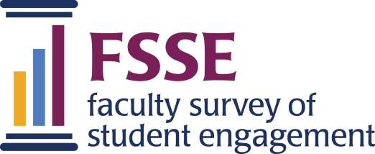

WHAT THIS SURVEY IS ABOUT
We cordially invite you to participate in the 2023 Faculty Survey of Student Engagement (FSSE). The information you and other instructional staff members on your campus provide will help identify areas of strength and improvement, as well as lead to constructive discussions related to teaching, learning, and the quality of your students' educational experience.
After reading the information on this page, if you agree to take part in this survey, click the "Proceed to the Survey" button below.

SURVEY PARTNERS
The Faculty Survey of Student Engagement is a project coordinated by the Center for Postsecondary Research at Indiana University Bloomington.

TAKING THE SURVEY
The survey takes about 18-25 minutes to complete. It is designed to measure instructional staff expectations regarding the extent to which students at your institution engage in educational practices empirically linked to high levels of learning and development.

CONFIDENTIALITY
Your school and the Center will make every effort to keep your responses confidential, although absolute confidentiality cannot be guaranteed. Personally identifying information (e.g., name or email address) will not be included in the data sent from the Center to your institution. No information associated with your name will ever be released publicly, but personally identifiable responses may be inspected by university and government organizations when required by law. Your participation in this study is voluntary and you may refuse to participate without penalty.

FURTHER INFORMATION
If you have technical problems completing the survey or have questions about the study, please contact Thomas Nelson Laird by email or by phone (812-856-5824).
If you feel you have not been treated according to the descriptions in this form, or your rights as a participant in research have not been honored during the course of this project, you may contact the office for the Human Subjects Committee, Carmichael Center 203, 530 E. Kirkwood Ave., Bloomington, IN 47405, 812-856-4242, or by email at irb@iu.edu.

Study #0212000011 | IRB Approval Date: February 8, 2022

Text after declining participation
We will remove your name from our contact list.
If you decide to participate in the future, you can return to the survey site
[LINK]
For security purposes, please close this browser window to exit the survey.

Final comments
If you have any additional comments you would like to make, please type them below (5,000 character limit).
[TEXT LIMITED TO 5000 CHARACTERS]

Survey is closed
The Faculty Survey of Student Engagement is now closed.
If you have any questions, please contact the FSSE Project Team at fsse@indiana.edu or 812-856-5824.

Completed survey
THANKS FOR SHARING YOUR RESPONSES!
Your responses to the survey were successfully submitted.
Questions or comments? Contact us.
For security purposes, please close your browser window to exit the survey.

