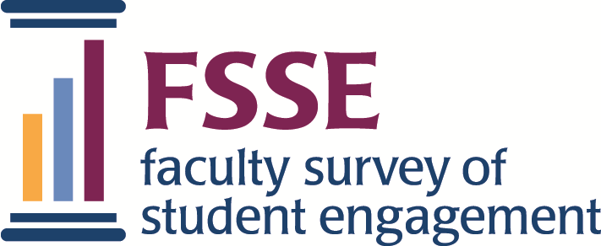

FSSE 2021 Guide to Data &
Report Resources

Accessing Your Results Online
FSSE provides zip files with respondent data and institutional reports that you can download from the “Data & Reports” table on the Institution Interface. Go to “Institution Login” in the upper right corner of the FSSE website (fsse.indiana.edu) and log in with your username and password.

About Your FSSE Administration

FSSE Overview
A profile of participating institutions and respondents including response rates, tips for checking data quality, and ideas for communicating FSSE results.

Survey Instruments
Facsimiles of the online FSSE items as they appear to instructional staff, including codebooks and consent text, for the main survey, Topical Modules, and consortium questions.

FSSE Scales
Information about FSSE Scales, parallel to NSSE Engagement Indicators, and their component items.

Working with FSSE Data
These guides and resources can help you make use of your FSSE data and results.

Analysis Resources
Syntax and tips for working with FSSE data

Data User’s Guide
Suggestions and worksheets for sharing results
with others
How Institutions Use FSSE Data
Examples of how participating institutions have used FSSE data and reports

Using FSSE Data
A guide with topics and tips to help you make use of your FSSE results.

Webinars
Free, interactive, and prerecorded webinars.

FSSE Results
Findings from FSSE can help you contextualize your results and provide data for benchmarking and aspirational purposes.

Aggregate Results
Aggregate results for a given FSSE administration year.

Content Summaries
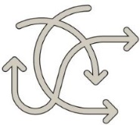
Brief overviews of findings from FSSE content areas.

Data Visualizations
Aggregate, interactive visualizations of FSSE results using Tableau.

Psychometric Portfolio
A collection of validity evidence for FSSE findings and other psychometric information about FSSE content

Publications and Presentations
FSSE results in scholarly papers and presentations

Contact Us!
FSSE staff are a great resource to help you with any questions about making use of your data and reports.
fsse@indiana.edu

Center for Postsecondary Research • Indiana University School of Education • 201 N. Rose Ave. • Bloomington, IN 47405
812-856-5824 | fsse@indiana.edu | fsse.indiana.edu | Twitter: @NSSEsurvey, @NSSEinstitute | Facebook: @NSSEsurvey | Blog: NSSEsightings.indiana.edu

