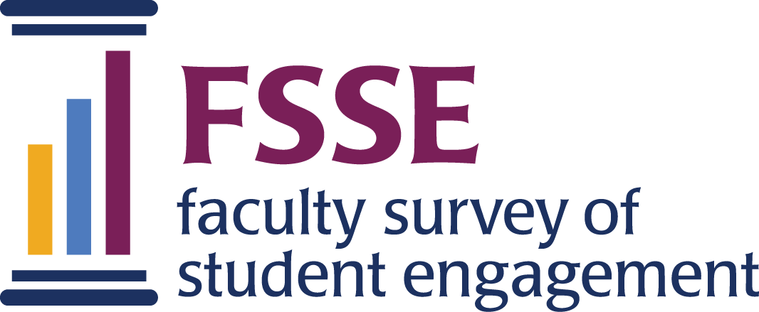

FSSE Data User’s Guide: Worksheet #1
Guiding Questions

By now, you have read through your institutional reports and are ready to start using your data. Knowing where to begin can be overwhelming, especially with the array of reports and data at your disposal. Before you dive into your results, take a moment to identify your main intentions for pursuing faculty practices and expectations and the most appropriate audiences for this information at your institution. The following questions are a reflection activity to help frame contexts to consider, understand what results mean, and disseminate the findings.
1. Reflect on your reasons for administering the FSSE survey. What strengths, concerns, or points of interest do you want to know about your faculty’s practices and expectations for students?
2. Are there any FSSE Scale scores, or item-level results that you want to know more about? Do these matters require attention before results are shared with other audiences?
3. What are some prominent campus goals and priorities at your institution right now? Is first-year student retention a concern? Is strategic planning on the campus agenda? Are you preparing for reaffirmation of accreditation? Is there a program that you want to improve or develop for a certain faculty population? What are your institution’s priorities? Jot down these ideas to keep in mind as you move forward with presenting and using your FSSE results.
4. What audiences would be interested in or could benefit from a greater understanding of your FSSE results? Identify key groups from and add to this list of offices and people to consider:
✓ Accreditation organization(s)  ✓ Alumni  ✓ Board of trustees  ✓ Center for teaching and learning  ✓ Faculty and departments  ✓ Faculty development  ✓ Faculty learning communities | ✓ Faculty senate and committees  ✓ General education assessment committees  ✓ Internal and external media  ✓ Prospective students and parents  ✓ State agencies and commissions  ✓ Student affairs offices and units

