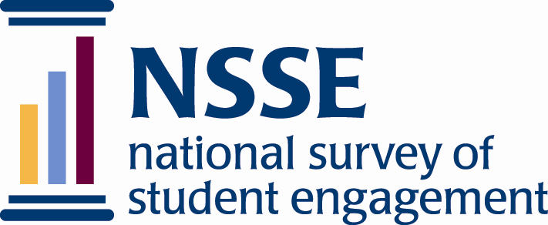

Proposal to Use NSSE Items

The National Survey of Student Engagement’s (NSSE) survey instrument, The College Student Report, is copyrighted and the copyright is owned by The Trustees of Indiana University. Any use of survey items contained within
The College Student Report is prohibited without prior written permission from Indiana University.

In addition, as a non-subsidized, cost-recovery project, the NSSE program may ask researchers who wish to borrow from, adapt, or translate the NSSE instrument to pay a fair price for the time and effort the NSSE staff put into forming such Agreements, and as reasonable estimate of the value of NSSE’s intellectual property.

In addition, such Agreements typically entail the following terms briefly described below, but to appear in formal legal detail in the actual Agreement:

- That all details of the license be negotiated in advance and in writing, which is incorporated by reference into the Agreement;
- The Agreement does not include any right to sublicense others. Any different or repeated use of the item(s) require an additional license;
- The researcher agrees:
  - To provide to NSSE frequency distributions and means on the licensed item(s);
  - On the survey form itself, and in all publications or presentations of data obtained through the licensed item(s), to note that the items were used with permission from Indiana University;
  - To provide to NSSE a copy of all surveys that include NSSE items or modified items; and
  - To provide to NSSE a copy of all reports, presentations, analyses, or other materials in which the borrowed item(s) are presented, discussed, or analyzed.
- The Agreement will include an expiration date.
- Other terms as deemed necessary to govern the Agreement as determined by either party.

Proposal to Use NSSE Items

Contact information:

Date

Last Name | First Name

Title

Institution

Office

Address

City | State/Province | Zip or Postal Code | Country

Phone | Fax

Email

Please briefly answer the following questions. You may attach additional documents in support of the proposal.

- How many faculty will be participating?

- How many classes will be included?

- When will the CLASSEs be administered?

- How will the CLASSEs be administered?

- Have you used or adapted any NSSE or FSSE item and included them as one of your optional 8 course-specific items?

- Are you a student working on your dissertation? If yes, please include your advisor’s name and title below.

