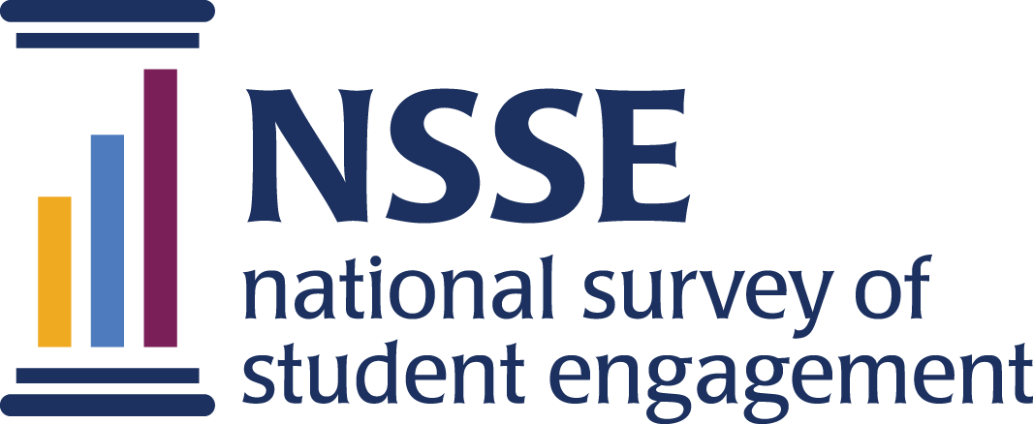

NSSE 2023 Data Codebooks
Mission Engagement Consortium for
Independent Colleges
Survey questions are listed in the order that students received them. Response options appear in italics beneath. Variable names appear in brackets (e.g., [MEC01a]) after each item. Items that are recoded (e.g., reversed response values) or derived (new computed values such as age category or total number of written pages) from original question(s) are shaded and prefaced by a bracket and the word "RECODED" or "DERIVED."

NSSE codebooks correspond to the final data we deliver in the summer and contain information on variables (EIs, recodes, derived variables, etc.) not included in the raw data files available for download in the spring. Like NSSE data, codebooks are subject to revision until the Institutional Report is delivered in August.

Mission Engagement Consortium for Independent Colleges

We would like you to answer some additional questions regarding your undergraduate experience. These questions take about two minutes to answer. Your continued participation is voluntary.

1. Every institution has a mission statement. We would like to know how familiar you are with your school's mission. Please indicate your agreement with each of the following statements:
Response options: Strongly disagree=1, Disagree=2, Neither agree/disagree=3, Agree=4, Strongly agree=5
a. The mission of this institution is widely understood by students. [MEC01a]
b. Ethical and spiritual development of students is an important part of the mission at this institution. [MEC01b]
c. This institution offers opportunities for volunteering and community service. [MEC01c]
d. Social and personal development of students is an important part of the mission at this institution. [MEC01d]
e. This institution offers opportunities for developing leadership skills. [MEC01e]
f. Preparation for a career is an important part of the mission of this institution. [MEC01f]
g. The heritage of the founders/founding religious community of this institution is evident here. [MEC01g]
h. The faculty and staff here are respectful of people of different religions. [MEC01h]
i. The students here are respectful of people of different religions. [MEC01i]
j. Students at this institution feel free to express their individual spirituality. [MEC01j]
k. The faculty and staff here are respectful of people of different races and cultures. [MEC01k]
l. The students here are respectful of people of different races and cultures. [MEC01l]
m. People of different sexual orientations are accepted socially here. [MEC01m]
n. The environment here encourages students to develop an appreciation of diversity. [MEC01n]
o. At this institution, there are opportunities for students to strengthen their religious commitment. [MEC01o]
p. The mission of this institution is reflected in its course offerings. [MEC01p]
q. As a result of my experience here, I am more aware of social justice (fairness and equality) issues in the world. [MEC01q]
r. The faculty at this institution discuss the ethical implications of what is being studied. [MEC01r]
s. As a result of my experience here, I am more aware of my own personal values. [MEC01s]

2. Current religious preference: (Mark only one.) [MEC02]
Response options: Baptist=1, Buddhist=2, Eastern Orthodox=3, Episcopalian=4, Hindu=5, Islamic=6, Jewish (Orthodox)=7, Jewish (Conservative)=8, Jewish (Reform)=9, Jewish (Unaffiliated)=10, LDS (Mormon)=11, Lutheran=12, Methodist=13, Presbyterian=14, Quaker=15, Roman Catholic=16, Seventh Day Adventist=17, Unitarian/Universalist=18, United Church of Christ=19, Other Christian=20, Other religion=21, None=22
Consortium page duration in minutes [DurationMEC]

