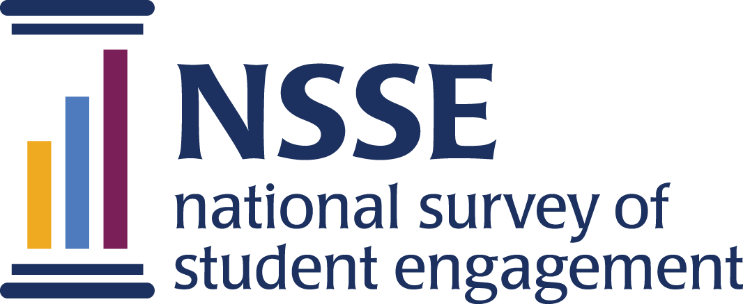
NSSE 2023 Data Codebooks
Seventh Day Adventist
Colleges & Universities Consortium
Survey questions are listed in the order that students received them. Response options appear in italics beneath. Variable names appear in brackets (e.g., [SDA01a]) after each item. Items that are recoded (e.g., reversed response values) or derived (new computed values such as age category or total number of written pages) from original question(s) are shaded and prefaced by a bracket and the word "RECODED" or "DERIVED."

NSSE codebooks correspond to the final data we deliver in the summer and contain information on variables (EIs, recodes, derived variables, etc.) not included in the raw data files available for download in the spring. Like NSSE data, codebooks are subject to revision until the Institutional Report is delivered in August.

Seventh Day Adventist Colleges & Universities Consortium

We would like you to answer some additional questions regarding your undergraduate experience. These questions take about 2 minutes to answer. Your continued participation is voluntary.
Seventh-day Adventist colleges and universities are committed to the spiritual growth of their students. We would like to know more about you and your experience in our institutions. Thank you for answering the following questions:

1. Please indicate your current religious affiliation: [SDA01]
Response options: Seventh-day Adventist=1, Other Protestant=2, Catholic=3, Other Christian=4, Jewish=5, Other religion=6, None=7

Please indicate your agreement with the following statements:
Response options: Strongly Agree=5, Agree=4, Neither agree/disagree=3, Disagree=2, Strongly Disagree=1

2. At my college/university…
a. I am aware of the mission. [SDA02a]
b. In addition to the Religion faculty, my professors in other departments discuss the ethical implications of what is being studied. [SDA02b]
c. I have evaluated my own beliefs and values. [SDA02c]
d. My professors have encouraged me to be a thoughtful follower of Jesus. [SDA02d]
e. Extracurricular activities reflect the mission. [SDA02e]

3. As a result of my experience at my college/university…
a. I have an enhanced understanding of the beliefs and values of the Seventh-day Adventist church. [SDA03a]
b. The Bible has become more relevant to my life. [SDA03b]
c. I am more inclined to act in ways that improve my health. [SDA03c]
d. I have a more mature faith. [SDA03d]
e. I am more committed to social justice (fairness and equality) in the world. [SDA03e]
f. I am more committed to understanding the will of God in my life. [SDA03f]

4. As a result of my experience at my college/university, I am more committed to the beliefs and values of the Seventh-day Adventist Church. [SDA04]
Response options: Strongly Agree=5, Agree=4, Neither agree/disagree=3, Disagree=2, Strongly disagree=1,
Not applicable (coded as missing)=9
[RECODED] To accommodate SAS users, recodes of question 4 “As a result of my experience at my college/university, I am more committed to the beliefs and values of the Seventh-day Adventist Church” are included in the data file to include “Not applicable” as a valid response. [SDA04R]
Values: Strongly disagree =1, Disagree =2, Neither agree/disagree =3, Agree =4, Strongly Agree =5, Not applicable=9

Please indicate how frequently you do the following at your college/university:
Response options: Very Often=4, Often=3, Sometimes=2, Never=1
a. Have conversations about spiritual values with fellow students outside of class. [SDA05a]
b. Spend time in personal, individual devotions (prayer, reflection, Bible study, etc.). [SDA05b]
Consortium page duration in minutes [DurationSDA]

