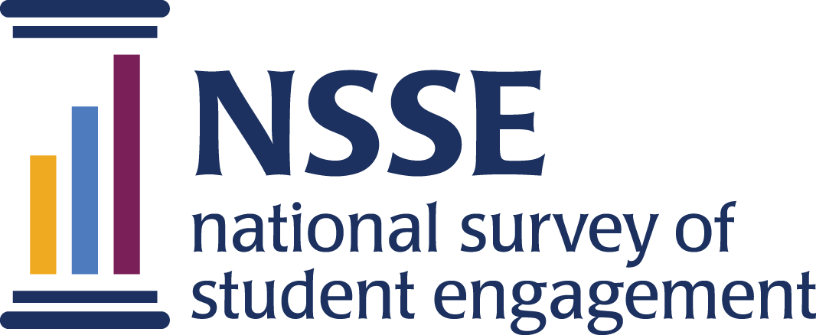
NSSE 2023 Data Codebooks
Inclusiveness & Engagement with Cultural Diversity Topical Module

This module examines environments, processes, and activities that reflect the engagement and validation of cultural diversity and promote greater understanding of societal differences. Questions explore students’ exposure to inclusive teaching practices and intercultural learning; perceptions of institutional values and commitment regarding diversity; and participation in diversity-related programming and coursework.
Survey questions are listed in the order that students received them. Response options appear in italics beneath. Variable names appear in brackets (e.g., [ICDskills]) after each item. Items that are recoded (e.g., reversed response values) or derived (new computed values such as age category or total number of written pages) from original question(s) are shaded and prefaced by a bracket and the word "RECODED" or "DERIVED."
NSSE codebooks correspond to the final data we deliver in the summer and contain information on variables (EIs, recodes, derived variables, etc.) not included in the raw data files available for download in the spring. Like NSSE data, codebooks are subject to revision until the Institutional Report is delivered in August.

Inclusiveness and Engagement with Cultural Diversity

1. During the current school year, how much has your coursework emphasized the following?
Response options: Very little=1, Some=2, Quite a bit=3, Very much=4
a. Developing the skills necessary to work effectively with people from various backgrounds [ICDskills]
b. Recognizing your own cultural norms and biases [ICDbiases]
c. Sharing your own perspectives and experiences [ICDperspective]
d. Exploring your own background through projects, assignments, or programs [ICDbackground]
e. Learning about other cultures [ICDcultures]
f. Discussing issues of equity or privilege [ICDequity]
g. Respecting the expression of diverse ideas [ICDideas]

2. How much does your institution emphasize the following?
Response options: Very little=1, Some=2, Quite a bit=3, Very much=4
a. Demonstrating a commitment to diversity [ICDcommitment]
b. Providing students with the knowledge and skills needed for success in a multicultural world [ICDresources]
c. Creating an overall sense of community among students [ICDcommunity]
d. Ensuring that you are not stigmatized because of your identity (racial/ethnic, gender, religious, sexual orientation, etc.) [ICDstigma]
e. Providing information about anti-discrimination and harassment policies [ICDdiscrimination]
f. Taking allegations of discrimination or harassment seriously [ICDallegations]
g. Helping students develop the skills to confront discrimination and harassment [ICDconfront]

3. How much does your institution provide a supportive environment for the following forms of diversity?
Response options: Very little=1, Some=2, Quite a bit=3, Very much=4
a. Racial/ethnic identity [ICDrace]
b. Gender identity [ICDgender]
c. Economic background [ICDecon]
d. Political affiliation [ICDpolitics]
e. Religious affiliation [ICDreligion]
f. Sexual orientation [ICDsexorient]
g. Disability status [ICDability]
h. Citizenship or immigration status [ICDcitizen]

4. During the current school year, about how often have you done the following?
Response options: Never=1, Sometimes=2, Often=3, Very often=4
a. Attended events, activities, or presentations that reflect an appreciation for diverse groups of people [ICDevents]
b. Participated in the activities of centers related to specific groups (racial-ethnic, cultural, religious, gender, LGBT, etc.) [ICDcenters]
c. Participated in a diversity-related club or organization [ICDclub]
d. Participated in a demonstration for a diversity-related cause (rally, protest, etc.) [ICDprotest]
e. Reflected on your cultural identity [ICDreflect]

