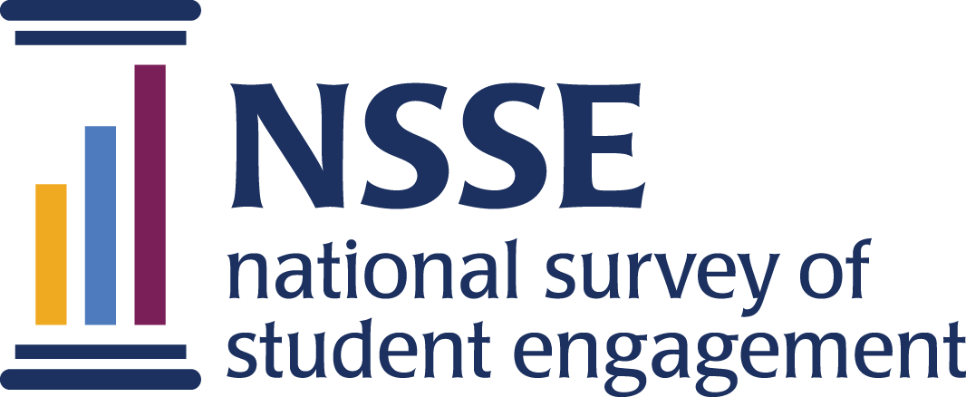

**NSSE 2025 Data Codebooks**

**Global Learning Experiences Topical Module**

NSSE's Global Learning Experiences module assesses student experiences and coursework that emphasize global affairs, world cultures, nationalities, and other international topics. The module pairs with items on the core NSSE questionnaire about student experiences with people from different backgrounds, course emphasis on integrative and reflective learning, and participation in study abroad. Items complement the American Council on Education's Mapping Internationalization on U.S. Campuses survey (2021) and UNESCO’s global citizenship education conceptual framework.

Survey questions are listed in the order that students received them. Response options appear in italics beneath. Variable names appear in brackets (e.g., [GBLemphasis]) after each item. Items that are recoded (e.g., reversed response values) or derived (new computed values such as age category or total number of written pages) from original question(s) are shaded and prefaced by a bracket and the word "RECODED" or "DERIVED."   
  
NSSE codebooks correspond to the final data we deliver in the summer and contain information on variables (EIs, recodes, derived variables, etc.) not included in the raw data files available for download in the spring. Like NSSE data, codebooks are subject to revision until the Institutional Report is delivered in August.

Global Learning Experiences Topical Module

# 1. How much emphasis does your institution place on courses and activities (speakers, events) that focus on global and international topics? [GBLemphasis]

Response options: Very much=4, Quite a bit=3, Some=2, Very little=1

# 2. Which of the following have you done, or do you plan to do before you graduate?

Response options: Have not decided=1, Do not plan to do=2, Plan to do=3, Done or in progress=4, To my knowledge is not available=9

a. Complete a course that primarily focuses on global trends or issues (human rights, international relations, world health, environment, peace studies, etc.) [GBLacttrend]

b. Complete a course that primarily focuses on perspectives, issues, or events from other countries or regions of the world [GBLactworld]

c. Use technology to virtually engage or collaborate with international communities, experts, and/or students at universities around the globe [GBLacttech]

d. Participate in international experiences *besides* study abroad, such as global-service learning, international internship, Model UN, field study, research abroad, etc. [GBLactintexp]

e. Participate in a special course or program that brings domestic and international students together (language partners, buddy program, etc.) [GBLacttogeth]

# 3. During the current school year, how much has your *coursework* encouraged you to do the following?

Response options: Very much=4, Quite a bit=3, Some=2, Very little=1

a. Understand the viewpoints, values, or customs of diverse cultures, nationalities, and religions [GBLcrscustoms]

b. Develop skills for interacting effectively and appropriately with those from various cultures, nationalities, and religions [GBLcrsinteract]

c. Learn about global or international perspectives with students or instructors from diverse cultural backgrounds [GBLcrsdiverse]

# 4. During the current school year, about how often have you done the following?

Response options: Very often=4, Often=3, Sometimes=2, Never=1

a. Taken a course that focuses on global and international topics [GBLoftcourse]

b. Discussed international or global topics and issues with others [GBLoftdiscuss]

c. Talked with a faculty member, advisor, or staff about international opportunities (study abroad, international internship, Model UN, field study or research abroad, etc.) [GBLoftintopps]

d. Attended events or activities that promoted the understanding of diverse cultures, nationalities, or regions of the world [GBLoftattend]

e. Worked on out-of-class activities (campus events, committees, student groups, etc.) with an international or global focus [GBLoftout]

f. Interacted with students from a country other than your own [GBLoftcountry]

# 5. During the current school year, which of the following sources of information about global education programs and opportunities (study abroad, international internships, international field studies or research, volunteering abroad, etc.) have you used or reviewed? (Select all that apply.)

Response options: Not selected=0, Selected=1

* Study abroad or international studies office [GBLinfo_intoffice]
* Major/academic department office [GBLinfo_major]
* Career office [GBLinfo_career]
* Academic advisor [GBLinfo_advisor]
* Faculty member [GBLinfo_faculty]
* Attendance at international programs or events [GBLinfo_event]
* Website, social media, newsletter, academic catalog, or other published sources [GBLinfo_web]
* Peers, study abroad returnees, friends, or other students [GBLinfo_peer]
* Family members [GBLinfo_family]
* Other, please specify: [GBLinfo_oth]
* None of the above [GBLinfo_none]

- Other, please specify: [GBLinfo_oth_txt]

Response options: Text box

Note: Item was only given if the student selected 'Other, please specify' in item 5

# 6. How much has your experience at this institution contributed to your knowledge, skills, and personal development in the following areas?

Response options: Very much=4, Quite a bit=3, Some=2, Very little=1

a. Being accurately informed about current international and global issues [GBLpgcurrent]

b. Speaking another language [GBLpglang]

c. Seeking international or global opportunities out of your comfort zone [GBLpgcomfort]

d. Understanding how your actions affect global communities [GBLpgactions]

e. Openness to communicating within diverse cultures [GBLpgopen]

f. Preparing for life and work in an increasingly globalized era [GBLpgprepare]

g. Developing your sense of global responsibility [GBLpgrespon]

h. Acting to make the world a more equitable and sustainable place [GBLpgsustain]