April 2021
HIPs in Practice Survey Administration Options
To participate in HIPs in Practice, institutions and programs must be able to identify students who will be involved in one of the designated HIPs in Spring 2021. All undergraduate students participating in one of these HIPs are eligible for HIPs in Practice. The survey will be administered at no cost to the institution.
We have two options for survey administration, described below.
The HIPs in Practice project administers your survey.
We send all emails on a set schedule. We need a population file (example pictured below) that contains:
student first name
student last name
student primary email address
which HIP or program student is participating in. Can be program names, course codes, or both, but must be unique
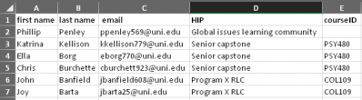

You administer your HIPs in Practice survey.
You send invitations and reminders. We’ll provide links to the survey, and a sample reminder schedule. Links will be specific to HIPs or program and must be shared carefully. We need a list of HIPs or programs you intend to survey (example pictured below). Can be program names, course codes, or both, but must be unique.
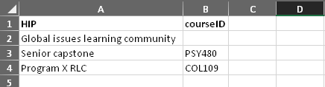
All participating institutions will receive a dataset containing all valid student responses, and a summary report for each HIP or program. Self-administered survey responses cannot be linked to other student information systems.

